-------------------------------------------------------
7 color led module 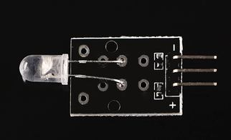
7 color flashing LED module uses automatic 5mm round high-brightness light-emitting diode, which has the following characteristics:

1) Product Type: LED

2) Model: YB-3120B4PnYG-PM

3) Product shape: Hole 5mm round light-emitting diode

4) Color: 7color
5) Lens Type: White mist

6) Standard Forward Voltage: 3.0-4.5V

/*
Blink
Turns on an LED on for two second, then off for two second, repeatedly.

This example code is in the public domain.
*/

void setup() {
// initialize the digital pin as an output.
// Pin 13 has an LED connected on most Arduino boards:
pinMode(13, OUTPUT);
}

void loop() {
digitalWrite(13, HIGH); // set the LED on
delay(2000); // wait for a second
digitalWrite(13, LOW); // set the LED off
delay(2000); // wait for a second
}

